
CS 181L – Applications of Information and Communication Technologies
lab # 02
My Computer's CPU and GPU
––
Student Name: Athar Imran
Student ID: 2604277

Assignment Date: 23st September, 2026
Assignment done: 23nd September, 2026
Due Date: 23th September, 2026

Task 1: Check Your CPU
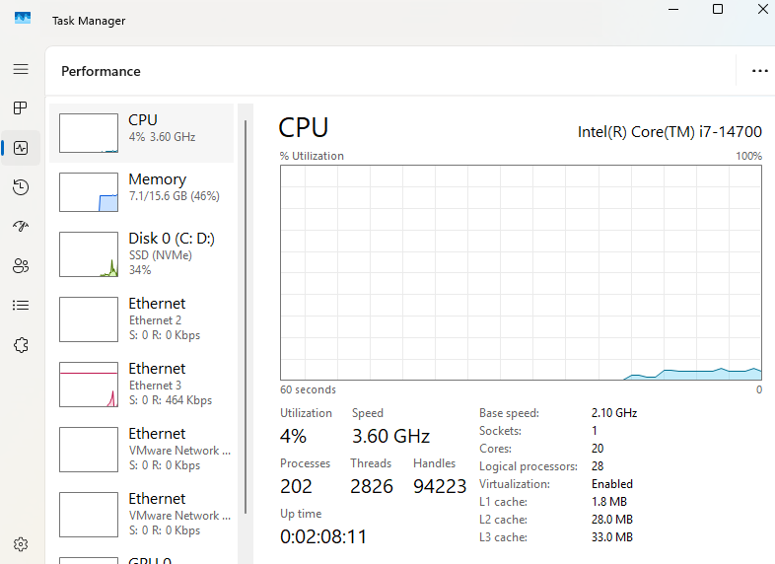
Figure 1 - My CPU

CPU Name: | Intel Core i7-14700
Base Speed: | 2.10GHz
Core: | 20
Logical Processor: | 28
Utilization: | 4%
Up Time | 02 minutes, 8 seconds

Task 2: Check Your GPU
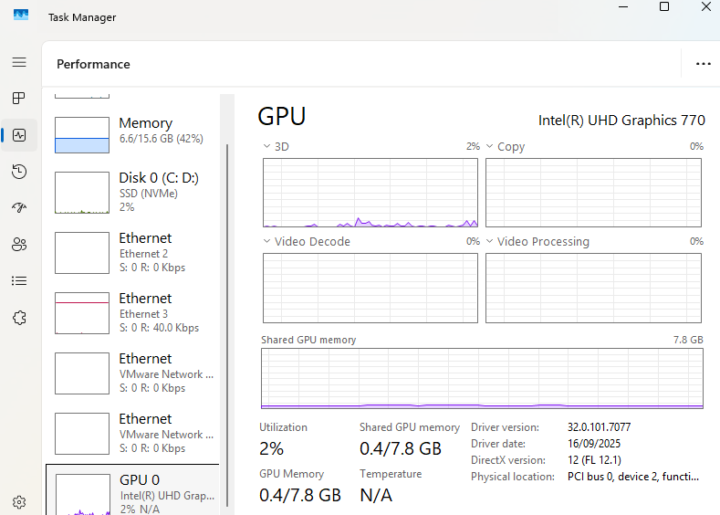
Figure 2 - My GPU

GPU name: | Intel UHD Graphics 770
Dedicated GPU memory (VRAM): | 7.8 GB
Driver version: | 32.0.101.7077
Utilisation: | 2%

Task 3: Compare Two Computers

Comparison | Computer A | Computer B | Better
CPU name | Intel Core i7-14700 | Intel Core i5-5600 | A
Base speed (GHz) | 2.10 GHz | 3.10 GHz | B
Cores | 20 | 8 | A
Logical processors | 28 | 12 | A
RAM | 16 | 8 | A
GPU name | Intel UHD Graphics 770 | No GPU | A
GPU memory | 8 | - | A

Task 4: Simple System Care

Turn off programs that start with Windows
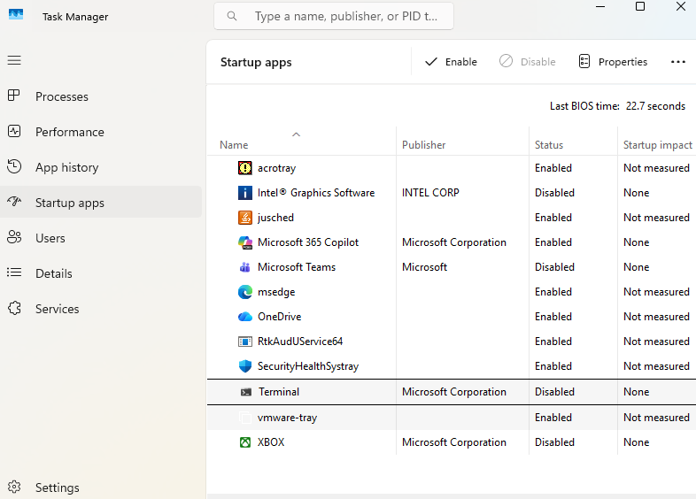
Figure 3 - Start up programs off
The unessccary programs at startup have been disabled to start at boot now.
Empty the Recycle Bin and restart
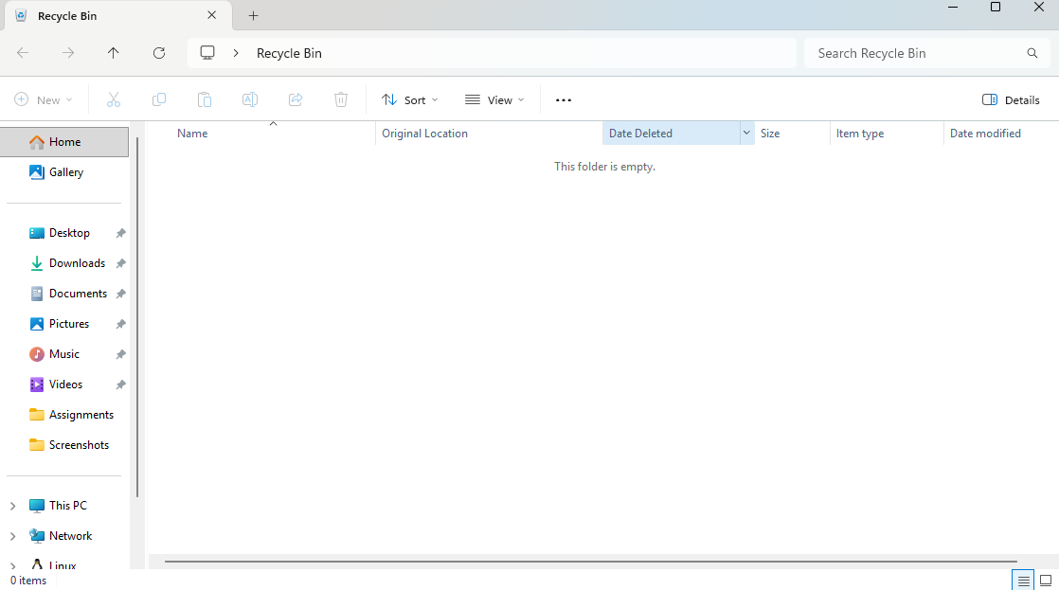
Figure 4 – Recyce bin
Recycle bin empted.

